Reproducible research assignment week 4

Types of storms and other severe weather events with highest impact on public health and economy in the US, based on 1950-2011 U.S. National Oceanic and Atmospheric Administration's (NOAA) data

##Download the file from NOAA's website

fileurl<-"<https://d396qusza40orc.cloudfront.net/repdata%2Fdata%2FStormData.csv.bz2>"

download.file(fileurl, destfile = "stormdata.csv.bz2")

##storm<-read.csv("stormdata.csv.bz2", header = TRUE, sep = ",", quote = "\"",...)

##Read the file into R

storm<-read.csv("stormdata.csv.bz2", header = TRUE)

##Check the structure of the file

str(storm)

##I believe it will be a good idea to convert all dates to date format, and also, even if I am not sure this will be useful, I will create another variable, EVTYPECH, that will be the conversion of the original EVTYPE to character.

storm$EVTYPECH<-as.character(storm$EVTYPE)

##It is reasonable to consider the number of fatalities as the main indicator of impact on health. Severity of the events should be determined based on this criterion. The number of injuries would be a secondary indicator, used to validate the first and to complement the understanding of the severity of the events.

stormhealth<-summarize(group_by(storm,EVTYPE),sfat=sum(FATALITIES,na.rm=T),sinj=sum(INJURIES,na.rm=T))

##storm<-transform(storm,BGN_DATE=as.Date(BGN_DATE,"%m/%d/%Y"), END_DATE=as.Date(END_DATE,"%m/%d/%Y"))

##max(storm$END_DATE,na.rm=T)

##[1] "2011-11-30"

##max(storm$BGN_DATE,na.rm=T)

##[1] "2011-11-30"

##stormhealth<-arrange(stormhealth,desc(sfat),desc(sinj))

##head(stormhealth)

# A tibble: 6 x 3

# EVTYPE sfat sinj

# <fct> <dbl> <dbl>

#1 TORNADO 5633 91346

#2 EXCESSIVE HEAT 1903 6525

#3 FLASH FLOOD 978 1777

#4 HEAT 937 2100

#5 LIGHTNING 816 5230

#6 TSTM WIND 504 6957

stormhealth<-arrange(stormhealth,sfat,sinj)

heatoptypes<-stormhealth[(nrow(stormhealth)-20):nrow(stormhealth),]

heabottypes<-stormhealth[1:, (nrow(stormhealth)-21)]

totbot<-summarize(heabottypes,sfat=sum(sfat),sinj=sum(sinj))

totbot<-mutate(totbot,EVTYPE="OTHER")

totbot<-select(totbot,EVTYPE,sfat,sinj)

heatypes<-rbind(totbot ,heatoptypes)

##dev.new()

wrapper <- function(x, ...)

{

paste(strwrap(x, ...), collapse = "\n")

}

main_title <-**"Health impact of storms and other events between 1950 and 2011 in the US – Number of fatalities"**

g<-ggplot(heatypes,aes(x=factor(EVTYPE,level=EVTYPE),y=sfat))+geom_col(aes(fill=EVTYPE))+theme_bw()+theme(**axis.text.x = element_text(size=8,angle=85,vjust=0.6),axis.text.y=element_text(size=8)**)+theme(axis.line = element_line(colour = "blue"), panel.border = element_blank())+theme(legend.position="none"**)+labs(x="Event Type",y="Fatalities",size=9)**+ ggtitle(wrapper(main_title, width = 50))+scale_y_continuous(labels=scales::comma_format(accuracy=1), expand = c(0, 0),breaks= c(seq(0,max(heatypes$sfat),by=500) , max(heatypes$sfat)))+geom_hline(yintercept=max(heatypes$sfat),linetype="dashed",color="violet")+coord_flip()

##print(g)

##dev.new()

inj_title <-**"Health impact of storms and other events between 1950 and 2011 in the US – Number of injuries"**

h<-ggplot(heatypes,aes(x=factor(EVTYPE,level=EVTYPE),y=sinj))+geom_col(aes(fill=EVTYPE))+theme_bw()+theme(**axis.text.x = element_text(size=8,angle=85,vjust=0.6),axis.text.y=element_text(size=8)**)+theme(axis.line = element_line(colour = "blue"), panel.border = element_blank())+theme(legend.position="none"**)+labs(x="Event Type",y="Injured people",size=9)**+ ggtitle(wrapper(inj_title, width = 50))+scale_y_continuous(labels=scales::comma_format(accuracy=1), expand = c(0, 0),breaks= c(seq(0,max(heatypes$sinj),by=20000) , max(heatypes$sinj)))+geom_hline(yintercept=max(heatypes$sinj),linetype="dashed",color="violet")+coord_flip()

##print(h)

health<-ggarrange(g,h,labels=c("F", "I"),ncol = 2, nrow = 1)

print(health)

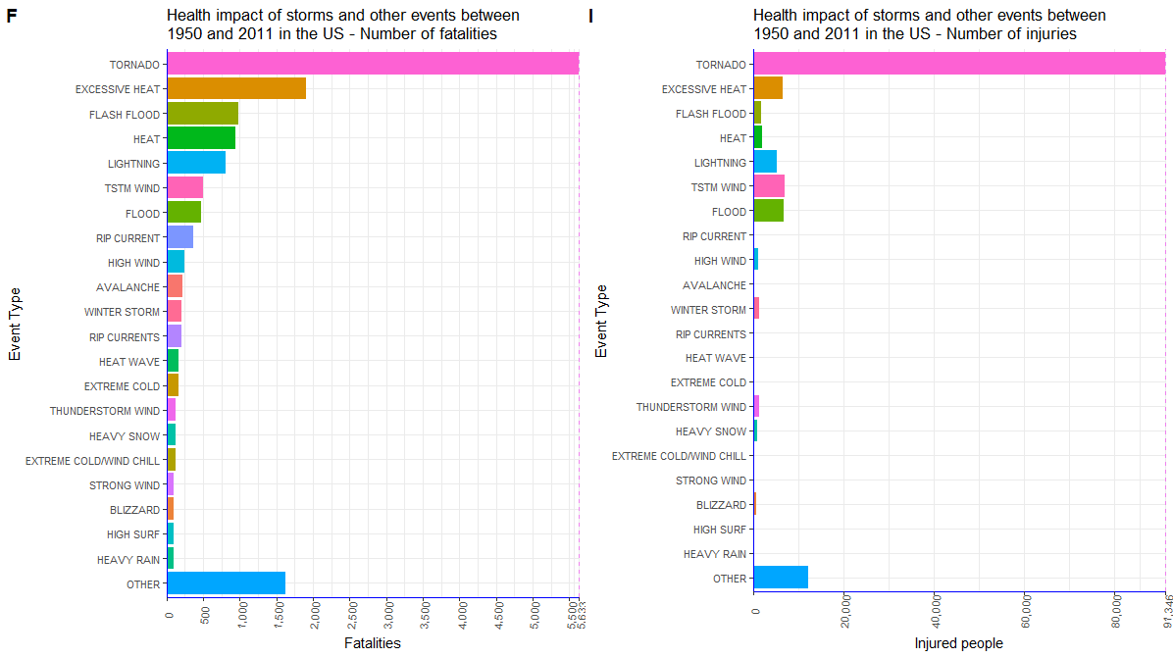

It is evident that tornadoes are clearly the atmospheric event with highest impact in health, followed by excessive heat and flash flood.

#> filter(stormhealth,sfat==max(sfat))

# A tibble: 1 x 3

# EVTYPE sfat sinj

# <fct> <dbl> <dbl>

#1 TORNADO 5633 91346

#> filter(stormhealth,sinj==max(sinj))

# A tibble: 1 x 3

# EVTYPE sfat sinj

# <fct> <dbl> <dbl>

#1 TORNADO 5633 91346

WATCHOUT,starting on row

368798

The dataset is a mess for abot 2k rows

**##ECONOMIC IMPACT**

stormunits<-transform(storm, PROPDMGEXP=as.character(PROPDMGEXP), CROPDMGEXP=as.character(CROPDMGEXP),PROPDMG=ifelse(storm$PROPDMGEXP=="K",PROPDMG*1000, ifelse(storm$PROPDMGEXP=="M",PROPDMG*10^6, ifelse(storm$PROPDMGEXP=="B",PROPDMG*10^9,PROPDMG))),

CROPDMG=ifelse(storm$CROPDMGEXP=="K",CROPDMG*1000, ifelse(storm$CROPDMGEXP=="M",CROPDMG*10^6, ifelse(storm$CROPDMGEXP=="B",CROPDMG*10^9,CROPDMG))))

stormdmg<-summarize(group_by(stormunits,EVTYPE),sprop =sum(PROPDMG,na.rm=T),scrop=sum(CROPDMG,na.rm=T),totdmg=sprop+scrop)

stormdmg<-arrange(stormdmg,totdmg,sprop,scrop)

stormdmg2<-transform(stormdmg,scrop= formatC**(**as.numeric**(scrop)**,format="f",digits=0,big.mark=","**),sprop=** formatC**(**as.numeric**(sprop)**,format="f",digits=0,big.mark=","**),totdmg=** formatC**(**as.numeric**(totdmg)**,format="f",digits=0,big.mark=","**))**

ecotoptypes<-stormdmg[(nrow(stormdmg)-20):nrow(stormdmg),]

ecobottypes<-stormdmg[1:(nrow(stormdmg)-21),]

totbot<-summarize(ecobottypes,sprop=sum(sprop),scrop=sum(scrop),totdmg=sprop+scrop)

totbot<-mutate(totbot,EVTYPE="OTHER")

totbot<-select(totbot,EVTYPE,sprop,scrop,totdmg)

ecotypes<-rbind(totbot,ecotoptypes)

ecotypes2<- transform(ecotypes,scrop= formatC**(**as.numeric**(scrop)**,format="f",digits=0,big.mark=","**),sprop=** formatC**(**as.numeric**(sprop)**,format="f",digits=0,big.mark=","**),totdmg=** formatC**(**as.numeric**(totdmg)**,format="f",digits=0,big.mark=","**))**

##head(ecotypes2)

## EVTYPE sprop scrop totdmg

##1 FLOOD 144,657,709,807 5,661,968,450 150,319,678,257

##2 HURRICANE/TYPHOON 69,305,840,000 2,607,872,800 71,913,712,800

##3 TORNADO 56,925,660,790 414,953,270 57,340,614,060

##4 STORM SURGE 43,323,536,000 5,000 43,323,541,000

##5 HAIL 15,727,367,053 3,025,537,890 18,752,904,943

##6 FLASH FLOOD 16,140,812,067 1,421,317,100 17,562,129,167

wrapper <- function(x, ...)

{

paste(strwrap(x, ...), collapse = "\n")

}

##pdf("total_impact.pdf", width=4, height=6)

##dev.new()

main_title <-**"Total economic impact of storms and other events between 1950 and 2011 in the US"**

p<-ggplot(ecotypes,aes(x=factor(EVTYPE,level=EVTYPE),y=totdmg))+geom_col(aes(fill=EVTYPE))+theme_bw()+theme(**axis.text.x = element_text(size=10,angle=85,vjust=0.6),axis.text.y = element_text(size=7)**)+ theme(axis.line = element_line(colour = "blue"), panel.border = element_blank())+theme(legend.position="none"**)+labs(x="Event Type",y="BILLION USD",size=6)**+ theme(plot.title = element_text(size=12))+ggtitle(wrapper(main_title, width = 30))+scale_y_continuous(labels=function(x)x/10^9,expand = c(0, 0))+geom_hline(yintercept=max(ecotypes$totdmg),linetype="dashed",color="violet")+coord_flip()

##print(p)

##dev.copy2pdf(file="total_impact.pdf",width=20, height=40)

##dev.off()

##dev.new()

prop_title<-" **Economic impact of storms and other events on property between 1950 and 2011 in the US"**

m<-ggplot(ecotypes,aes(x=factor(EVTYPE,level=EVTYPE),y=sprop))+geom_col(aes(fill=EVTYPE))+ theme_bw()+theme(**axis.text.x = element_text(size=8,angle=85,vjust=0.6),axis.text.y=element_text(size=7)**)+theme(axis.line = element_line(colour = "blue"), panel.border = element_blank())+theme(legend.position="none"**)+labs(x="Event Type",y="BILLION USD",size=6)**+ theme(plot.title = element_text(size=12))+ggtitle(wrapper(prop_title, width = 30))+scale_y_continuous(labels=function(x)x/10^9, expand = c(0, 0))+geom_hline(yintercept=max(ecotypes$sprop),linetype="dashed",color="violet")+coord_flip()

##print(m)

##dev.new()

crop_title<-" **Economic impact of storms and other events on crops between 1950 and 2011 in the US"**

n<-ggplot(ecotypes,aes(x=factor(EVTYPE,level=EVTYPE),y=scrop))+geom_col(aes(fill=EVTYPE))+ theme_bw()+theme(**axis.text.x = element_text(size=8,angle=85,vjust=0.6),axis.text.y=element_text(size=7)**)+theme(axis.line = element_line(colour = "blue"), panel.border = element_blank())+theme(legend.position="none"**)+labs(x="Event Type",y="BILLION USD",size=6)**+ theme(plot.title = element_text(size=12))+ggtitle(wrapper(crop_title, width = 30))+scale_y_continuous(labels=function(x)x/10^9, expand = c(0, 0))+geom_hline(yintercept=max(ecotypes$scrop),linetype="dashed",color="violet")+coord_flip()

##print(n)

economic<-ggarrange(p,m,n,labels=c("", "",""),ncol = 3, nrow = 1)

print(economic)

